How to claim your CME/CEU Credit
For Users With CME WebTracker Passwords
Thank you for attending the Albemarle County Medical Society Educational Session titled
Physician Employment Contracts –
Presented by John Davidson, Esq.
February 6, 2014--Activity Code: 20463
NOTE: Please use Internet Explorer if using a PC or Firefox if using a MAC product AND ALLOW
popups

You may need to hold down your Ctrl key while clicking on this link http://cmetracker.net/UVACME/Login?FormName=getCertificate or enter this url in your browser

You should see the image below titled
‘CME Certificate’-Sign in-Welcome!’

- At this screen please enter your FULL Email Address.

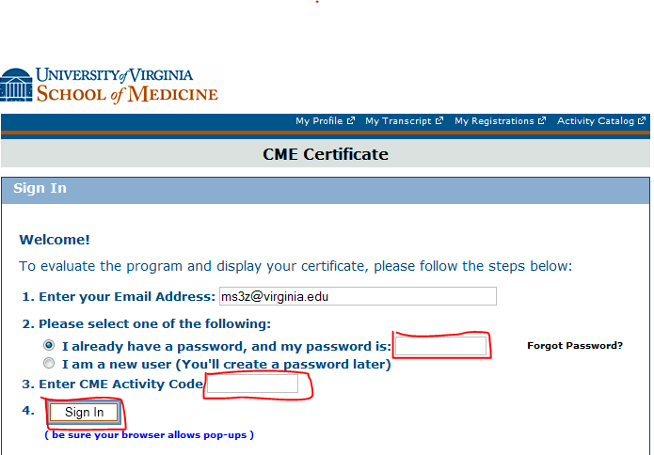

- SELECT: “I already have a password, and my password is: and enter your password
- Enter your activity code: 20463 Click Sign In.

- If your password doesn’t work please click on Forgot Password to reset it.
- This brings you to the evaluation for this conference, complete it.

- Submit the evaluation.

- This brings you to the Claim Credit page. This page assigns the credit that you are eligible for that matches the events eligibility.

- Click ‘Continue’, then click ‘Display Certificate’ so you can print the certificate.
- For problems, please contact Terri Ellison (tme6n@virginia.edu or 243-0858) in UVA’s CME office.

