How to claim your CME/CEU Credit-For New Users
Without CME WebTracker Passwords
Thank you for attending the Albemarle County Medical Society Educational Session titled
Physician Employment Contracts
By John Davidson, Esq.
February 6, 2014 - Activity Code: 20463
Instructions on how to create your password, complete your evaluation and print your certificate for new users of UVA’s CME Evaluation System (called CME Tracker)

NOTE: Please use Internet Explorer if using a PC or Firefox if using a MAC product:

- Hold down your Ctrl key while clicking on this link http://cmetracker.net/UVACME/Login?FormName=getCertificate

OR enter this url in your browser and you will should see the image below titled
‘CME Certificate’-Sign in-Welcome!’

- At this screen please enter your FULL Email Address

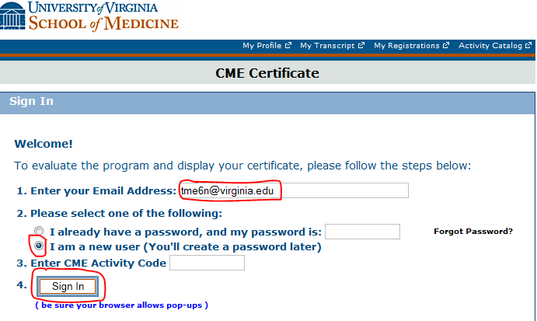

SELECT: “I am a new user” and Select Sign In.
- (For new users) this screen will pop up next. Even though you are a NEW USER the system is trying to see if you are registered and it searches by your birthdate and last name

Enter your last name and birthdate
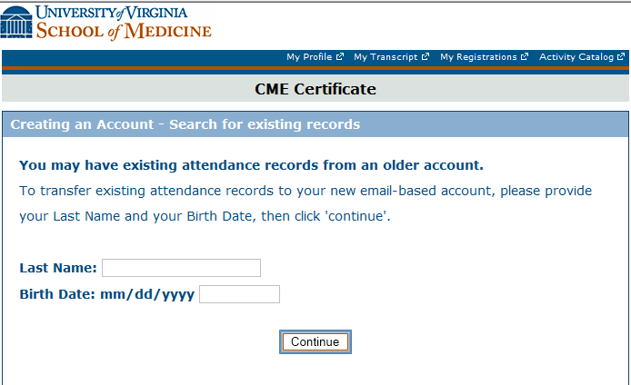
4. Next this screen will pop up so you can create your CME password. You only need to fill in the required * areas so you can create a CME password.
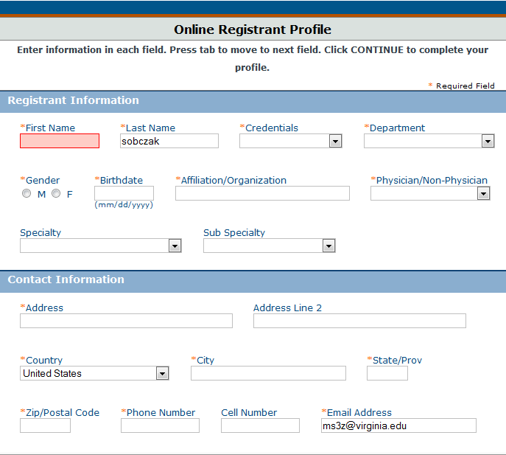

5. After you have created your password the system will return you to this screen so you can enter your newly created password AND your activity code: 20463
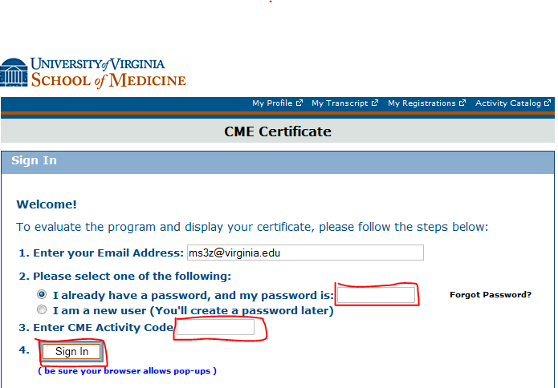
6. On line #3 enter the CME Activity Code 20463

7. Click on Sign in.

8. This brings you to the evaluation for this conference, complete it.

9. Submit the evaluation.

10. This brings you to the Claim Credit page. This page assigns the credit that you are eligible for that matches the events eligibility.

11. Click ‘Continue’, then click ‘Display Certificate’ so you can print the certificate.

12. For problems, contact Terri Ellison (tme6n@virginia.edu or 243-0858) in UVA’s CME office.

